UNITED STATES
SECURITIES AND EXCHANGE COMMISSION
Washington, D.C. 20549
_________________
FORM 8-K
_________________
CURRENT REPORT
Pursuant to Section 13 or 15(d)
of the Securities Exchange Act of 1934
Date of Report (Date of earliest event reported): July 13, 2026
_______________________________
AEBI SCHMIDT HOLDING AG
(Exact name of registrant as specified in its charter)
_______________________________
Switzerland | 001-42663 | Not Applicable
(State or Other Jurisdiction of Incorporation) | (Commission File Number) | (I.R.S. Employer Identification No.)
Schulstrasse 4
Frauenfeld, Switzerland CH-8500
(Address of Principal Executive Offices) (Zip Code)
+41 44-308-5800
(Registrant's telephone number, including area code)
Not Applicable
(Former name or former address, if changed since last report)
_______________________________
Check the appropriate box below if the Form 8-K filing is intended to simultaneously satisfy the filing obligation of the registrant under any of the following provisions:
☐ | Written communications pursuant to Rule 425 under the Securities Act (17 CFR 230.425)
☐ | Soliciting material pursuant to Rule 14a-12 under the Exchange Act (17 CFR 240.14a-12)
☐ | Pre-commencement communications pursuant to Rule 14d-2(b) under the Exchange Act (17 CFR 240.14d-2(b))
☐ | Pre-commencement communications pursuant to Rule 13e-4(c) under the Exchange Act (17 CFR 240.13e-4(c))
Securities registered pursuant to Section 12(b) of the Act:
Title of each class | Trading Symbol(s) | Name of each exchange on which registered
Common Stock | AEBI | The NASDAQ Stock Market LLC
Indicate by check mark whether the registrant is an emerging growth company as defined in Rule 405 of the Securities Act of 1933 (§230.405 of this chapter) or Rule 12b-2 of the Securities Exchange Act of 1934 (§240.12b-2 of this chapter).
Emerging growth company ☐
If an emerging growth company, indicate by check mark if the registrant has elected not to use the extended transition period for complying with any new or revised financial accounting standards provided pursuant to Section 13(a) of the Exchange Act. ☐

Item 7.01. Regulation FD Disclosure.

On July 13, 2026, Aebi Schmidt Holding AG (“Aebi Schmidt”) issued the press release and investor presentation, attached hereto as Exhibits 99.1 and 99.2, respectively, regarding Aebi Schmidt’s business and long-term strategy.

The information contained in this Item 7.01 and Exhibits 99.1 and 99.2, attached hereto, is being furnished and shall not be deemed “filed” for purposes of Section 18 of the Securities Exchange Act of 1934, as amended (the “Exchange Act”), and shall not be deemed incorporated by reference into any filing with the Securities and Exchange Commission under the Exchange Act or the Securities Act of 1933, as amended, whether made before or after the date hereof and irrespective of any general incorporation language in any such filings.

Item 9.01. Financial Statements and Exhibits.

(d) Exhibits.

The following exhibits are filed herewith:

Exhibit No. |  | Description
99.1 |  | Press Release dated July 13, 2026
99.2 |  | Investor Presentation dated July 13, 2026
104 |  | Cover Page Interactive Data File (embedded within the Inline XBRL document)

SIGNATURE
Pursuant to the requirements of the Securities Exchange Act of 1934, as amended, Aebi Schmidt Holding AG has duly caused this report to be signed on its behalf by the undersigned hereunto duly authorized.
 | AEBI SCHMIDT HOLDING AG
Date: July 13, 2026 | By: | /s/ Barend Fruithof
 | Name: | Barend Fruithof
 | Title: | Group CEO
Date: July 13, 2026 | By: | /s/ Marco Portmann
 | Name: | Marco Portmann
 | Title: | Group CFO

EXHIBIT 99.1
Aebi Schmidt Group Marks One Year After the Acquisition of The Shyft Group and NASDAQ Listing: Delivering on Commitments and Outlining the Long-Term Growth Strategy
- During the year following the acquisition of The Shyft Group and its NASDAQ listing, Aebi Schmidt Group delivered on its strategic and financial commitments, successfully executing the integration, increasing its annual synergy target, and advancing multiple strategic initiatives including new product launches, acquisitions, partnerships, simplified brand architecture, and expansion of facilities
- Company outlines its long-term strategy to realize more than $3b of annual revenue and a mid-teen adjusted EBITDA margin by 2030, leveraging its global market leadership, resilient business model and profitable growth tailwinds, as detailed in its accompanying investor presentation, which is available in the Investor Relations section of the Company's website at www.aebi-schmidt.com/investors
FRAUENFELD, Switzerland, July 13, 2026 (GLOBE NEWSWIRE) -- Aebi Schmidt Holding AG (NASDAQ: AEBI) (“Aebi Schmidt Group”, the “Group” or the “Company”), a world-class specialty vehicles leader, celebrates one year since its acquisition of The Shyft Group and listing on NASDAQ, highlighting its strong execution against the targets and commitments made since transaction and outlining its long-term growth strategy.
Over the past year, Aebi Schmidt Group has delivered on its targets and commitments since the time of the acquisition of The Shyft Group, including meaningful progress across all areas:
- The combined business operated effectively from day one, thanks to the commitment and collaboration of employees across both organizations, providing the foundation for the Group's strong operational and financial performance
- The annual run-rate synergy target has been raised from $25m to $30m pre-merger to at least $40m today, delivering higher cost savings and further improved operational excellence
- Aebi Schmidt launched the new ServicePRO truck body at the NTEA show in March 2026, with first deliveries scheduled to begin in the third quarter of 2026, and significantly expanded the total addressable market in the Airport business line, with the introduction of new product solutions for general aviation airports
- The Company expanded its reach through the opening and ramp-up of the new Chicago Super Center, bringing multiple products and service lines under one roof, and new upfit centers in Toronto and Minnesota
- The brand portfolio has been streamlined, from more than 20 brands to a focused 11-brand architecture, reducing complexity, strengthening customer engagement, and improving communication efficiency
- Customer relationships have been strengthened, gaining deals from strategic customers such as a recent $15m contract from an e-commerce customer (with a framework agreement of up to $42m), an $11m award to maintain German highways, and multiple landmark deals in Airport, including a $46m win from Airport de Paris
- Strategic partnerships have been developed, entering an agreement with Yeti Move to advance airport and winter fleet automation in North America, with exclusive US market rights, accelerating autonomous airside operations
- Integration of other recent acquisitions, such as LWS and Ladog, have been completed, reinforcing the Group’s growth platform for the future
Driven by this sustained execution across all strategic priorities, Aebi Schmidt Group experienced strong market momentum with Order Intake growing 29% year-over-year1, delivering substantially improved profitability with adjusted EBITDA growth of 21% year-over-year since the acquisition.1
“We have delivered on our commitments, and built a stronger company, combining the strengths of Aebi Schmidt and the former Shyft Group,” said Barend Fruithof, Chairman and Chief Executive Officer of Aebi Schmidt Group. “I would like to thank all our employees for their commitment, collaboration and dedication throughout this integration. Their efforts have enabled the combined business to operate successfully from day one and have laid the foundation for our continued growth. With a successful integration behind us and a clear strategy ahead, we believe we are well-positioned to drive profitable growth and create long-term value for our shareholders.”
Building on this strong foundation, Aebi Schmidt Group is focused on its next phase of growth. As a global leader in specialty vehicles, the Company is targeting more than $3b in annual revenue and a mid-teen adjusted EBITDA margin by 2030, supported by its resilient business model and opportunities for profitable growth. The strategy underpinning these ambitions is detailed in the Company's newly released investor presentation, which is available in the Investor Relations section of the Company's website at www.aebi-schmidt.com/investors and in the Current Report on Form 8-K furnished by the Company to the SEC today.
_____________________________
[1] Year-over-year growth compares the post-acquisition period from Q3 2025 to Q1 2026 with the pro forma combined results for the corresponding period from Q3 2024 to Q1 2025. Financial results up until June 30, 2025, provided as basis for comparison to our Q3 2025 to Q1 2026 performance, include results for Aebi Schmidt and The Shyft Group on a combined basis inclusive of the period prior to the merger on July 1, 2025. This also applies to Q3 2024 to Q1 2025 figures used as the basis for year-over-year comparisons in this release, which are presented on a combined basis as if the merger had closed on January 1, 2024. Historical information presented on a combined basis does not reflect any pro-forma adjustments or adjustments for costs related to integration activities, cost savings or synergies that have occurred or may be achieved if the merger occurred on January 1, 2024.
Media contact  Tina Fischer, Corporate Communication  media@aebi-schmidt.com  Phone: +41 44 308 58 48  Investor Contact  Simone Grancini, Director Investor Relations  investor.relations@aebi-schmidt.com  Phone: +41 44 308 58 77 | Further information  https://www.aebi-schmidt.com  https://www.youtube.com/user/AebiSchmidtGroup  https://media.aebi-schmidt.com (pictures, logos)
About Aebi Schmidt Group
Aebi Schmidt Group (NASDAQ: AEBI) is a world-class specialty vehicles leader, positioned to accelerate growth and drive exceptional value. The Company is headquartered in Switzerland, employs approximately 6,000 employees, and operates production facilities and service and upfit centers across Europe and North America.
Forward-looking statements
This release contains information, including our outlook for future periods, and other statements concerning our business, strategic position, financial projections, financial strength, future plans, objectives, and the performance of our products and operations that may constitute "forward-looking statements" within the meaning of Section 27A of the Securities Act of 1933, as amended, and Section 21E of the Securities Exchange Act of 1934, as amended. We intend the forward-looking statements to be covered by the safe harbor provisions for forward-looking statements in those sections. Generally, we have identified such forward-looking statements by using words such as "believe," "expect," "intend," "potential," "future," "may," "will," "should," and similar expressions or by using future dates or targets in connection with any discussion of, among other things, the construction or operation of new or existing facilities, operating performance, trends, events or developments that we expect or anticipate will occur in the future, statements relating to volume changes, share of sales and earnings per share changes, anticipated cost savings and attainment of merger synergies, potential capital and operational cash improvements, changes in supply and demand conditions and prices for our products, trade duties and other aspects of trade policy, statements regarding our future strategies, products and innovations, and statements expressing general views about future operating results. However, the absence of these words or similar expressions does not mean that a statement is not forward-looking. Forward-looking statements are not historical facts, but instead represent only Aebi Schmidt's beliefs regarding future events, many of which, by their nature, are inherently uncertain and outside of Aebi Schmidt's control. It is possible that Aebi Schmidt's actual results and financial condition may differ, possibly materially, from the anticipated results and financial condition indicated in these forward-looking statements. Management believes that these forward-looking statements are reasonable as of the time made. However, caution should be taken not to place undue reliance on any such forward-looking statements because such statements speak only as of the date when made. We undertake no obligation to publicly update or revise any forward-looking statements, whether as a result of new information, future events or otherwise, except as required by law. In addition, forward-looking statements are subject to certain risks and uncertainties that could cause actual results to differ materially from Aebi Schmidt's historical experience and our present expectations or projections. More information about factors that potentially could affect our results is included in our filings with the SEC, which are available at www.sec.gov or our website. All forward-looking statements in this release are qualified by this paragraph. Investors should not place undue reliance on forward-looking statements as a prediction of actual results.
Non-GAAP Financial Measures
To supplement its reporting of financial measures determined in accordance with generally accepted accounting principles in the United States ("GAAP"), Aebi Schmidt utilizes certain non-GAAP financial measures. Aebi Schmidt utilizes non-GAAP financial measures such as Adjusted EBITDA and Adjusted EBITDA margin to separate the impact of certain items from the underlying business. Because Aebi Schmidt uses these adjusted financial results in the management of its business, management believes this supplemental information is useful to investors for their independent evaluation and understanding of Aebi Schmidt's underlying business performance and the performance of its management. To aid investors and analysts with year-over-year comparability for the combined business of Aebi Schmidt and Shyft, the Company has also presented certain of these non-GAAP financial measures on a "Combined " basis. Combined non-GAAP financial measures include results for both Aebi Schmidt and Shyft on a combined basis inclusive of periods prior to the merger. Information presented on a combined basis does not reflect pro-forma adjustments or other adjustments for costs related to integration activities, cost savings or synergies that have been or may be achieved if the business combination occurred on January 1, 2024. The non-GAAP financial measures described above are in addition to, and not meant to be considered superior to, or a substitute for, Aebi Schmidt's financial statements prepared in accordance with GAAP. Non-GAAP financial measures have limitations in that they do not reflect all of the amounts associated with the Company's results of operations as determined in accordance with GAAP. Also, other companies might calculate these measures differently. Investors are encouraged to review the reconciliations of the non-GAAP financial measures to their most directly comparable GAAP measures included in this press release and the accompanying tables. In addition, the non-GAAP financial measures included in this release reflect management's judgment of particular items, and may be different from, and therefore may not be comparable to, similarly titled measures reported by other companies.
The Company did not provide reconciliations of forward-looking non-GAAP financial measures, such as Adjusted EBITDA margin, to the most comparable GAAP financial measure because the Company is unable to provide a meaningful or accurate calculation or estimation of reconciling items, and the information is not available without unreasonable effort. The Company is unable to address the probable significance of the unavailable information.
Aebi Schmidt Group
Combined Financial Summary (Non-GAAP, unaudited)1
(in thousands)
Financial results up until June 30, 2025, provided as basis for comparison to our Q3 2025 to Q1 2026 performance, include results for Aebi Schmidt and The Shyft Group on a combined basis inclusive of the period prior to the merger on July 1, 2025. This also applies to Q3 2024 to Q1 2025 figures used as the basis for year-over-year comparisons in this release, which are presented on a combined basis as if the merger had closed on January 1, 2024. Historical information presented on a combined basis does not reflect any pro-forma adjustments or adjustments for costs related to integration activities, cost savings or synergies that have occurred or may be achieved if the merger occurred on January 1, 2024.
Adjusted EBITDA ($k) | Q3 2024 | Q4 2024 | Q1 2025 | Q2 2025 | Q3 2025 | Q4 2025 | Q1 2026
Net Sales | 456,526 | 499,659 | 453,785 | 453,706 | 471,325 | 528,371 | 455,545
Net Income (Loss) | 7,445 | 6,068 | 626 | -7,895 | 1,194 | 8,772 | 671
Add (subtract)
Interest Expense | 11,125 | 10,138 | 9,164 | 12,153 | 14,228 | 11,761 | 11,350
Depreciation & amortization | 11,841 | 12,788 | 12,127 | 11,778 | 14,990 | 16,159 | 13,803
Income tax (benefit) / expenses | 1,501 | 2,215 | 1,441 | -2,175 | -447 | 2,036 | 488
Restructuring and other related charges | 186 | 759 | 730 | 5,709 | 12,759 | 6,391 | 4,216
Transaction related expenses and adjustments | 1,225 | 12,934 | 7,286 | 13,047 | 5,988 | 562 | 434
Foreign exchange losses on external debt | 1,095 | -590 | 982 | 2,601 | -252 | -371 | 300
Pension related income, net | -674 | -2,360 | -929 | -1,025 | -1,025 | -2,076 | -776
Other | -48 | -5,197 | -182 | 287 | -5,238 | 4,839 | 2,631
Adjusted EBITDA | 33,696 | 36,756 | 31,245 | 34,480 | 42,197 | 48,073 | 33,117
Adjusted EBITDA (as % of Net Sales) | 7.4% | 7.4% | 6.9% | 7.6% | 9.0% | 9.1% | 7.3%
For historical comparisons to the Shyft Group results, adjustments reflected in the table above do not include non-cash stock-based compensation expense.
Exhibit 99.2


public Aebi Schmidt Group Investor Presentation July 13, 2026

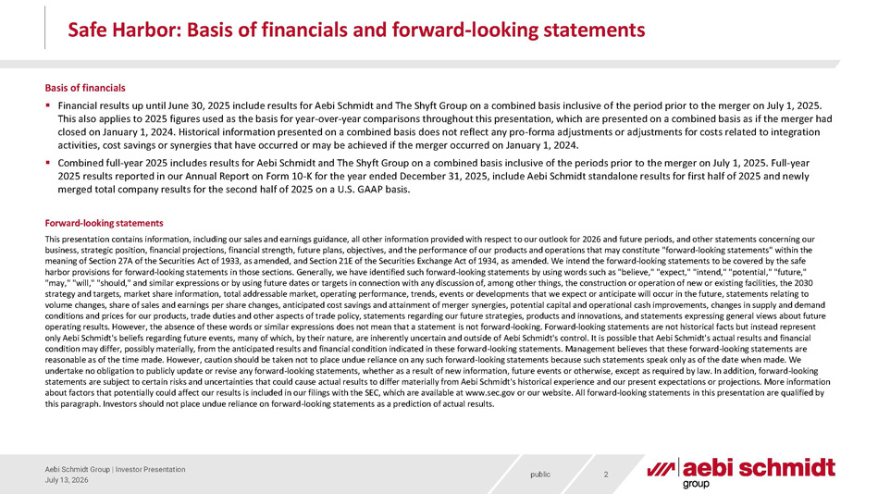
public July 13, 2026 Aebi Schmidt Group | Investor Presentation 2 Safe Harbor: Basis of financials and forward - looking statements Basis of financials ▪ Financial results up until June 30, 2025 include results for Aebi Schmidt and The Shyft Group on a combined basis inclusive o f t he period prior to the merger on July 1, 2025. This also applies to 2025 figures used as the basis for year - over - year comparisons throughout this presentation, which are prese nted on a combined basis as if the merger had closed on January 1, 2024. Historical information presented on a combined basis does not reflect any pro - forma adjustments or ad justments for costs related to integration activities, cost savings or synergies that have occurred or may be achieved if the merger occurred on January 1, 2024. ▪ Combined full - year 2025 includes results for Aebi Schmidt and The Shyft Group on a combined basis inclusive of the periods prior to the merger on July 1, 2025. Full - year 2025 results reported in our Annual Report on Form 10 - K for the year ended December 31, 2025, include Aebi Schmidt standalone re sults for first half of 2025 and newly merged total company results for the second half of 2025 on a U.S. GAAP basis. Forward - looking statements This presentation contains information, including our sales and earnings guidance, all other information provided with respect t o our outlook for 2026 and future periods, and other statements concerning our business, strategic position, financial projections, financial strength, future plans, objectives, and the performance of our pr oducts and operations that may constitute "forward - looking statements" within the meaning of Section 27A of the Securities Act of 1933, as amended, and Section 21E of the Securities Exchange Act of 1934, as ame nded. We intend the forward - looking statements to be covered by the safe harbor provisions for forward - looking statements in those sections. Generally, we have identified such forward - looking statement s by using words such as "believe," "expect," "intend," "potential," "future," " may," "will," "should," and similar expressions or by using future dates or targets in connection with any discussion of, amo ng other things, the construction or operation of new or existing facilities, the 2030 strategy and targets, market share information, total addressable market, operating performance, trends, events or developments that we expect or anticipate will occur in the future, statements relating to volume changes, share of sales and earnings per share changes, anticipated cost savings and attainment of merger synergies, p ote ntial capital and operational cash improvements, changes in supply and demand conditions and prices for our products, trade duties and other aspects of trade policy, statements regarding our future strat egi es, products and innovations, and statements expressing general views about future operating results. However, the absence of these words or similar expressions does not mean that a statement is not forward - look ing. Forward - looking statements are not historical facts but instead represent only Aebi Schmidt's beliefs regarding future events, many of which, by their nature, are inherently uncertain and outside of Aeb i Schmidt's control. It is possible that Aebi Schmidt's actual results and financial condition may differ, possibly materially, from the anticipated results and financial condition indicated in these forward - looki ng statements. Management believes that these forward - looking statements are reasonable as of the time made. However, caution should be taken not to place undue reliance on any such forward - looking stateme nts because such statements speak only as of the date when made. We undertake no obligation to publicly update or revise any forward - looking statements, whether as a result of new information, fut ure events or otherwise, except as required by law. In addition, forward - looking statements are subject to certain risks and uncertainties that could cause actual results to differ materially from Aebi Schm idt 's historical experience and our present expectations or projections. More information about factors that potentially could affect our results is included in our filings with the SEC, which are available at www.s ec. gov or our website. All forward - looking statements in this presentation are qualified by this paragraph. Investors should not place undue reliance on forward - looking statements as a prediction of actual results.

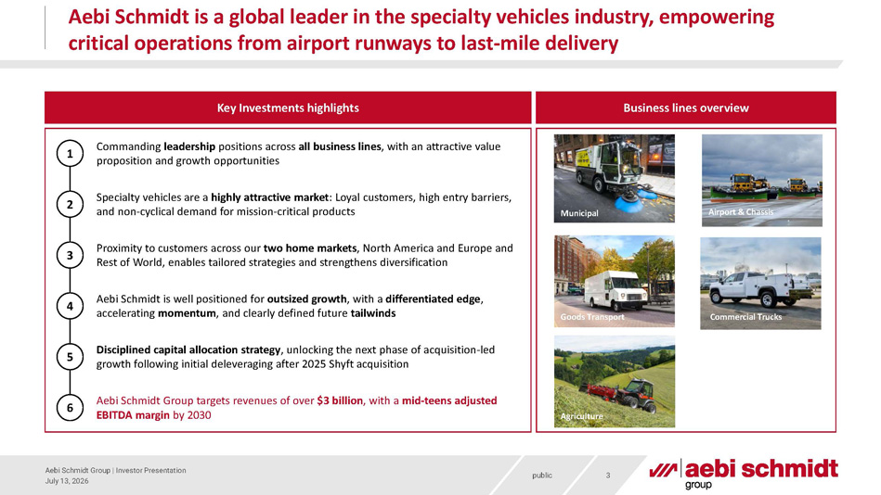
public Aebi Schmidt is a global leader in the specialty vehicles industry, empowering critical operations from airport runways to last - mile delivery 3 July 13, 2026 Aebi Schmidt Group | Investor Presentation Commanding leadership positions across all business lines , with an attractive value proposition and growth opportunities Specialty vehicles are a highly attractive market : Loyal customers, high entry barriers, and non - cyclical demand for mission - critical products Proximity to customers across our two home markets , North America and Europe and Rest of World, enables tailored strategies and strengthens diversification Aebi Schmidt is well positioned for outsized growth , with a differentiated edge , accelerating momentum , and clearly defined future tailwinds Aebi Schmidt Group targets revenues of over $3 billion , with a mid - teens adjusted EBITDA margin by 2030 Disciplined capital allocation strategy , unlocking the next phase of acquisition - led growth following initial deleveraging after 2025 Shyft acquisition Key Investments highlights Business lines overview Municipal Airport & Chassis Goods Transport Commercial Trucks Agriculture Goods Transport 1 2 3 4 5 6

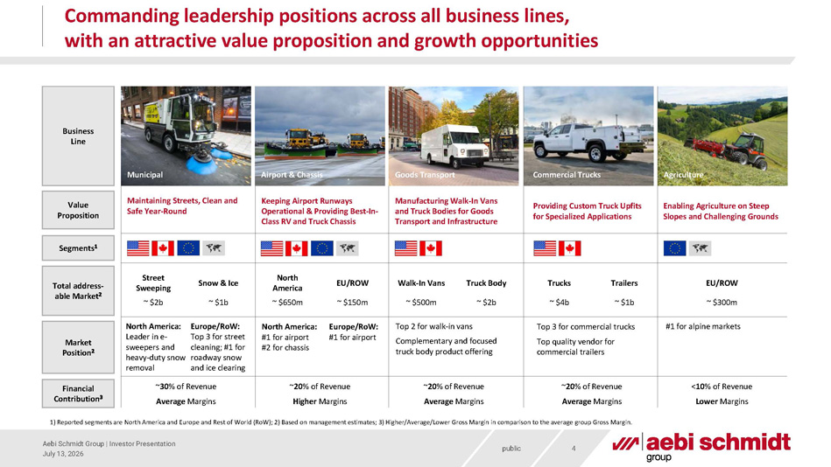
public Commanding leadership positions across all business lines, with an attractive value proposition and growth opportunities 4 July 13, 2026 Aebi Schmidt Group | Investor Presentation Total address - able Market 2 Market Position 2 Business Line Enabling Agriculture on Steep Slopes and Challenging Grounds Value Proposition Segments 1 EU/ROW ~ $300m #1 for alpine markets 1) Reported segments are North America and Europe and Rest of World (RoW); 2) Based on management estimates; 3) Higher/Averag e/L ower Gross Margin in comparison to the average group Gross Margin. Agriculture Financial Contribution 3 Providing Custom Truck Upfits for Specialized Applications Trucks Trailers ~ $4b ~ $1b Top 3 for commercial trucks Top quality vendor for commercial trailers Commercial Trucks ~ 20 % of Revenue Average Margins Manufacturing Walk - In Vans and Truck Bodies for Goods Transport and Infrastructure Walk - In Vans Truck Body ~ $500m ~ $2b Top 2 for walk - in vans Complementary and focused truck body product offering Goods Transport ~ 20 % of Revenue Average Margins Maintaining Streets, Clean and Safe Year - Round Street Sweeping Snow & Ice ~ $2b ~ $1b Europe / RoW: Top 3 for street cleaning; #1 for roadway snow and ice clearing North America: Leader in e - sweepers and heavy - duty snow removal Municipal ~ 30 % of Revenue Average Margins Keeping Airport Runways Operational & Providing Best - In - Class RV and Truck Chassis North America EU/ROW ~ $650m ~ $150m Europe/RoW: #1 for airport North America: #1 for airport #2 for chassis Airport & Chassis ~ 20 % of Revenue Higher Margins < 10 % of Revenue Lower Margins

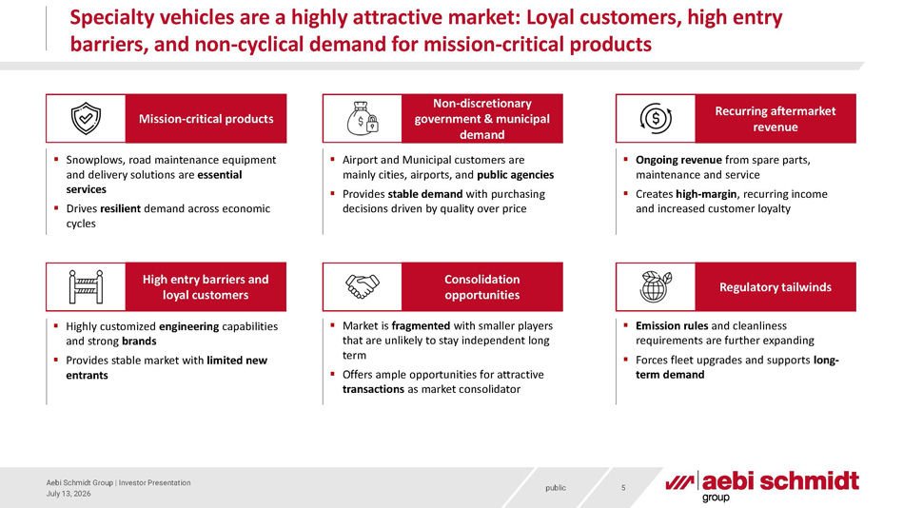
public Specialty vehicles are a highly attractive market: Loyal customers, high entry barriers, and non - cyclical demand for mission - critical products July 13, 2026 Aebi Schmidt Group | Investor Presentation 5 ▪ Snowplows, road maintenance equipment and delivery solutions are essential services ▪ Drives resilient demand across economic cycles ▪ Airport and Municipal customers are mainly cities, airports, and public agencies ▪ Provides stable demand with purchasing decisions driven by quality over price ▪ Ongoing revenue from spare parts, maintenance and service ▪ Creates high - margin , recurring income and increased customer loyalty ▪ Highly customized engineering capabilities and strong brands ▪ Provides stable market with limited new entrants ▪ Market is fragmented with smaller players that are unlikely to stay independent long term ▪ Offers ample opportunities for attractive transactions as market consolidator Mission - critical products Non - discretionary government & municipal demand Recurring aftermarket revenue High entry barriers and loyal customers Consolidation opportunities ▪ Emission rules and cleanliness requirements are further expanding ▪ Forces fleet upgrades and supports long - term demand Regulatory tailwinds

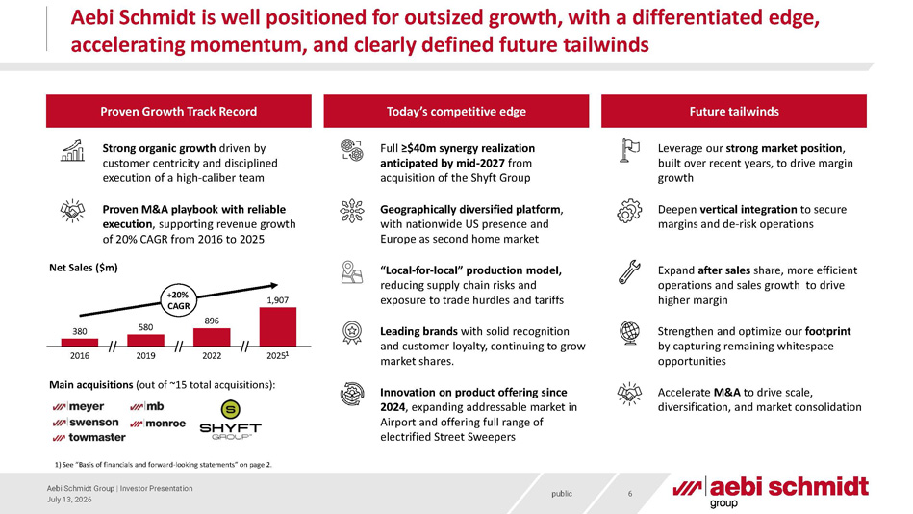
public Aebi Schmidt is well positioned for outsized growth, with a differentiated edge, accelerating momentum, and clearly defined future tailwinds 6 July 13, 2026 Aebi Schmidt Group | Investor Presentation Proven Growth Track Record Today’s competitive edge Full ≥$40m synergy realization anticipated by mid - 2027 from acquisition of the Shyft Group Proven M&A playbook with reliable execution , supporting revenue growth of 20% CAGR from 2016 to 2025 Future tailwinds 380 580 896 2016 2019 2022 2025 1 1,907 + 20% CAGR Net Sales ($m) Main acquisitions (out of ~15 total acquisitions): Strong organic growth driven by customer centricity and disciplined execution of a high - caliber team Geographically diversified platform , with nationwide US presence and Europe as second home market “Local - for - local” production model, reducing supply chain risks and exposure to trade hurdles and tariffs Leading brands with solid recognition and customer loyalty, continuing to grow market shares. Innovation on product offering since 2024 , expanding addressable market in Airport and offering full range of electrified Street Sweepers Deepen vertical integration to secure margins and de - risk operations Expand after sales share, more efficient operations and sales growth to drive higher margin Strengthen and optimize our footprint by capturing remaining whitespace opportunities Accelerate M&A to drive scale, diversification, and market consolidation 1) See “Basis of financials and forward - looking statements” on page 2. Leverage our strong market position , built over recent years, to drive margin growth

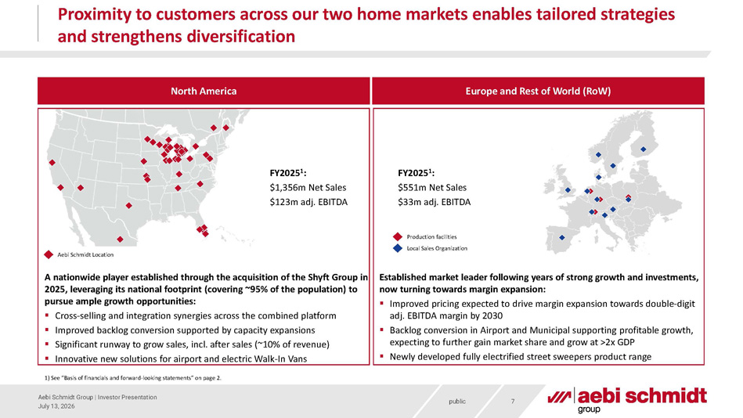
public Proximity to customers across our two home markets enables tailored strategies and strengthens diversification 7 July 13, 2026 Aebi Schmidt Group | Investor Presentation Production facilities Local Sales Organization Aebi Schmidt Location North America Europe and Rest of World (RoW) A nationwide player established through the acquisition of the Shyft Group in 2025, leveraging its national footprint (covering ~95% of the population) to pursue ample growth opportunities: ▪ Cross - selling and integration synergies across the combined platform ▪ Improved backlog conversion supported by capacity expansions ▪ Significant runway to grow sales, incl. after sales (~10% of revenue) ▪ Innovative new solutions for airport and electric Walk - In Vans FY2025 1 : $1,356m Net Sales $123m adj. EBITDA FY2025 1 : $551m Net Sales $33m adj. EBITDA Established market leader following years of strong growth and investments, now turning towards margin expansion: ▪ Improved pricing expected to drive margin expansion towards double - digit adj. EBITDA margin by 2030 ▪ Backlog conversion in Airport and Municipal supporting profitable growth, expecting to further gain market share and grow at >2x GDP ▪ Newly developed fully electrified street sweepers product range 1) See “Basis of financials and forward - looking statements” on page 2.

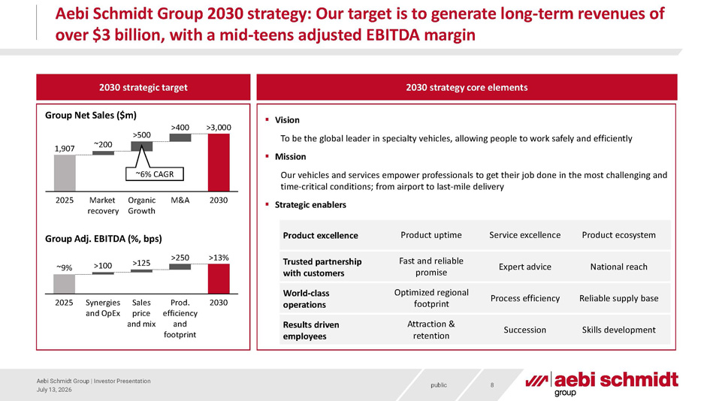
public Aebi Schmidt Group 2030 strategy: Our target is to generate long - term revenues of over $3 billion, with a mid - teens adjusted EBITDA margin 8 July 13, 2026 Aebi Schmidt Group | Investor Presentation 2030 strategy core elements 2030 strategic target 2025 Market recovery Organic Growth M&A 2030 1,907 ~200 >500 >400 >3,000 Group Net Sales ($m) 2025 Synergies and OpEx Sales price and mix Prod. efficiency and footprint 2030 ~9% >100 >125 >250 >13% Group Adj. EBITDA (%, bps) ▪ Vision To be the global leader in specialty vehicles, allowing people to work safely and efficiently ▪ Mission Our vehicles and services empower professionals to get their job done in the most challenging and time - critical conditions; from airport to last - mile delivery ▪ Strategic enablers Product excellence Trusted partnership with customers World - class operations Results driven employees Product uptime Service excellence Product ecosystem Fast and reliable promise Expert advice National reach Optimized regional footprint Process efficiency Reliable supply base Attraction & retention Succession Skills development ~6% CAGR

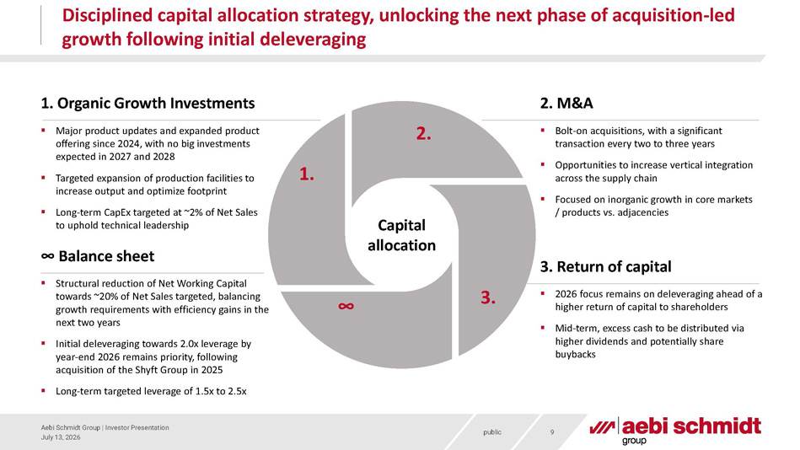
public Disciplined capital allocation strategy, unlocking the next phase of acquisition - led growth following initial deleveraging 9 July 13, 2026 Aebi Schmidt Group | Investor Presentation 2. ∞ 3. 1. Capital allocation ∞ Balance sheet 2. M&A 3. Return of capital 1. Organic Growth Investments ▪ Bolt - on acquisitions, with a significant transaction every two to three years ▪ Opportunities to increase vertical integration across the supply chain ▪ Focused on inorganic growth in core markets / products vs. adjacencies ▪ Structural reduction of Net Working Capital towards ~20% of Net Sales targeted, balancing growth requirements with efficiency gains in the next two years ▪ Initial deleveraging towards 2.0x leverage by year - end 2026 remains priority, following acquisition of the Shyft Group in 2025 ▪ Long - term targeted leverage of 1.5x to 2.5x ▪ 2026 focus remains on deleveraging ahead of a higher return of capital to shareholders ▪ Mid - term, excess cash to be distributed via higher dividends and potentially share buybacks ▪ Major product updates and expanded product offering since 2024, with no big investments expected in 2027 and 2028 ▪ Targeted expansion of production facilities to increase output and optimize footprint ▪ Long - term CapEx targeted at ~2% of Net Sales to uphold technical leadership

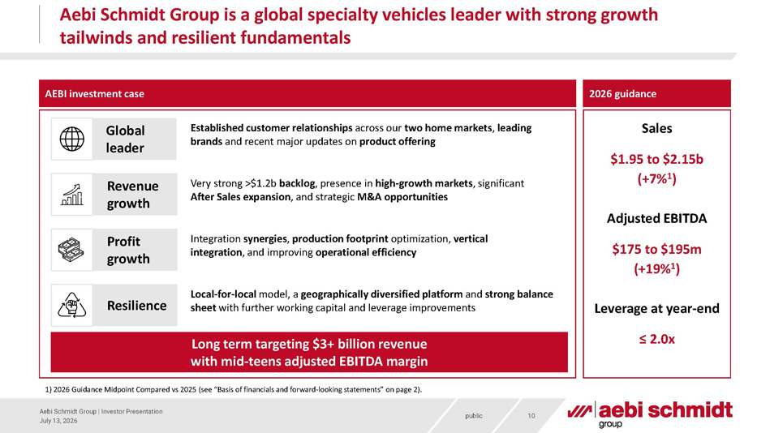
public Aebi Schmidt Group is a global specialty vehicles leader with strong growth tailwinds and resilient fundamentals 10 July 13, 2026 Aebi Schmidt Group | Investor Presentation Sales $1.95 to $2.15b (+7% 1 ) Adjusted EBITDA $175 to $195m (+19% 1 ) Leverage at year - end ≤ 2.0x 2026 guidance 1) 2026 Guidance Midpoint Compared vs 2025 (s ee “Basis of financials and forward - looking statements” on page 2). AEBI investment case Global leader Established customer relationships across our two home markets , leading brands and recent major updates on product offering Resilience Revenue growth Local - for - local model, a geographically diversified platform and strong balance sheet with further working capital and leverage improvements Very strong >$1.2b backlog , presence in high - growth markets , significant After Sales expansion , and strategic M&A opportunities Integration synergies , production footprint optimization, vertical integration , and improving operational efficiency Profit growth Long term targeting $3+ billion revenue with mid - teens adjusted EBITDA margin


public Appendix 11 July 13, 2026 Aebi Schmidt Group | Investor Presentation

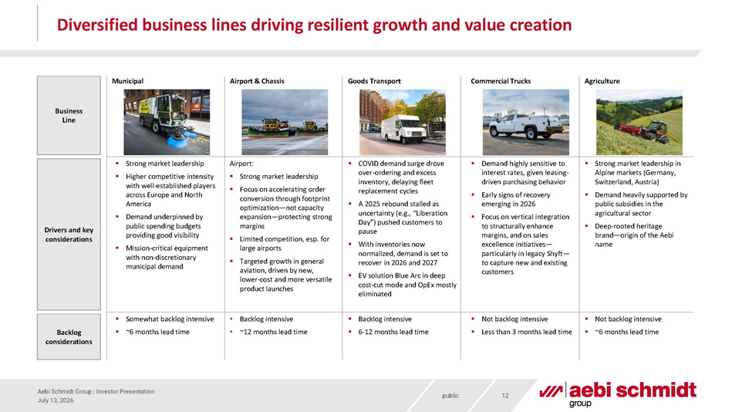
public Diversified business lines driving resilient growth and value creation 12 July 13, 2026 Aebi Schmidt Group | Investor Presentation Business Line Drivers and key considerations Goods Transport Agriculture ▪ COVID demand surge drove over - ordering and excess inventory, delaying fleet replacement cycles ▪ A 2025 rebound stalled as uncertainty (e.g., “Liberation Day”) pushed customers to pause ▪ With inventories now normalized, demand is set to recover in 2026 and 2027 ▪ EV solution Blue Arc in deep cost - cut mode and OpEx mostly eliminated ▪ Strong market leadership in Alpine markets (Germany, Switzerland, Austria) ▪ Demand heavily supported by public subsidies in the agricultural sector ▪ Deep - rooted heritage brand — origin of the Aebi name Backlog considerations Airport: ▪ Strong market leadership ▪ Focus on accelerating order conversion through footprint optimization — not capacity expansion — protecting strong margins ▪ Limited competition, esp. for large airports ▪ Targeted growth in general aviation, driven by new, lower - cost and more versatile product launches Airport & Chassis • Backlog intensive • ~12 months lead time Commercial Trucks ▪ Demand highly sensitive to interest rates, given leasing - driven purchasing behavior ▪ Early signs of recovery emerging in 2026 ▪ Focus on vertical integration to structurally enhance margins, and on sales excellence initiatives — particularly in legacy Shyft — to capture new and existing customers ▪ Not backlog intensive ▪ Less than 3 months lead time ▪ Backlog intensive ▪ 6 - 12 months lead time Municipal ▪ Strong market leadership ▪ Higher competitive intensity with well - established players across Europe and North America ▪ Demand underpinned by public spending budgets providing good visibility ▪ Mission - critical equipment with non - discretionary municipal demand ▪ Somewhat backlog intensive ▪ ~6 months lead time ▪ Not backlog intensive ▪ ~6 months lead time

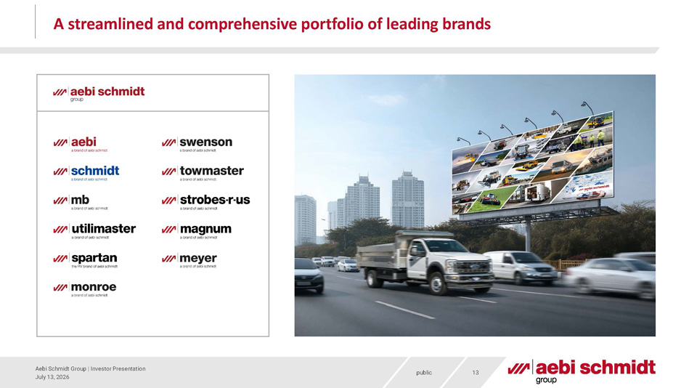
public A streamlined and comprehensive portfolio of leading brands 13 July 13, 2026 Aebi Schmidt Group | Investor Presentation

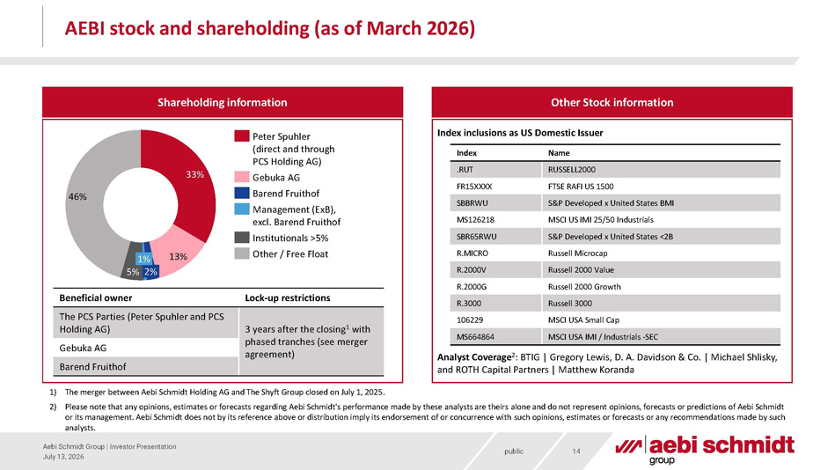
public AEBI stock and shareholding (as of March 2026) 14 July 13, 2026 Aebi Schmidt Group | Investor Presentation Shareholding information Other Stock information 33% 13% 5% 46% 2% 1% Peter Spuhler (direct and through PCS Holding AG) Gebuka AG Barend Fruithof Management (ExB), excl. Barend Fruithof Institutionals >5% Other / Free Float Lock - up restrictions Beneficial owner 3 years after the closing 1 with phased tranches (see merger agreement) The PCS Parties (Peter Spuhler and PCS Holding AG) Gebuka AG Barend Fruithof Name Index RUSSELL2000 .RUT FTSE RAFI US 1500 FR15XXXX S&P Developed x United States BMI SBBRWU MSCI US IMI 25/50 Industrials MS126218 S&P Developed x United States <2B SBR65RWU Russell Microcap R.MICRO Russell 2000 Value R.2000V Russell 2000 Growth R.2000G Russell 3000 R.3000 MSCI USA Small Cap 106229 MSCI USA IMI / Industrials - SEC MS664864 Index inclusions as US Domestic Issuer Analyst Coverage 2 : BTIG | Gregory Lewis, D. A. Davidson & Co. | Michael Shlisky, and ROTH Capital Partners | Matthew Koranda 1) The merger between Aebi Schmidt Holding AG and The Shyft Group closed on July 1, 2025 . 2) Please note that any opinions, estimates or forecasts regarding Aebi Schmidt's performance made by these analysts are theirs alo ne and do not represent opinions, forecasts or predictions of Aebi Schmidt or its management. Aebi Schmidt does not by its reference above or distribution imply its endorsement of or concurrence with suc h opinions, estimates or forecasts or any recommendations made by such analysts.

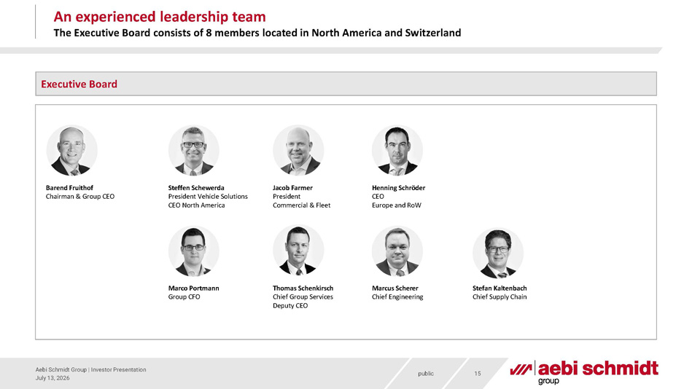
public 15 July 13, 2026 Aebi Schmidt Group | Investor Presentation Marcus Scherer Chief Engineering Barend Fruithof Chairman & Group CEO Stefan Kaltenbach Chief Supply Chain Thomas Schenkirsch Chief Group Services Deputy CEO Marco Portmann Group CFO Henning Schröder CEO Europe and RoW Jacob Farmer President Commercial & Fleet Steffen Schewerda President Vehicle Solutions CEO North America An experienced leadership team The Executive Board consists of 8 members located in North America and Switzerland Executive Board

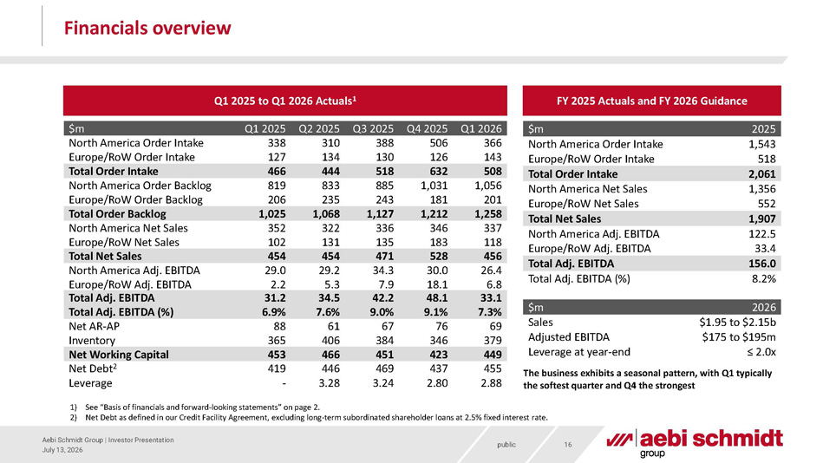
public Financials overview 16 July 13, 2026 Aebi Schmidt Group | Investor Presentation $m 2025 North America Order Intake 1,543 Europe/RoW Order Intake 518 Total Order Intake 2,061 North America Net Sales 1,356 Europe/RoW Net Sales 552 Total Net Sales 1,907 North America Adj. EBITDA 122.5 Europe/RoW Adj. EBITDA 33.4 Total Adj. EBITDA 156.0 Total Adj. EBITDA (%) 8.2% Q1 2025 to Q1 2026 Actuals 1 1) See “Basis of financials and forward - looking statements” on page 2. 2) Net Debt as defined in our Credit Facility Agreement, excluding long - term subordinated shareholder loans at 2.5% fixed interest rate. FY 2025 Actuals and FY 2026 Guidance $m Q1 2025 North America Order Intake 338 Europe/RoW Order Intake 127 Q2 2025 Q3 2025 Q4 2025 Q1 2026 310 388 506 366 134 130 126 143 Total Order Intake 466 444 518 632 508 North America Order Backlog 819 833 885 1,031 1,056 Europe/RoW Order Backlog 206 235 243 181 201 Total Order Backlog 1,025 1,068 1,127 1,212 1,258 North America Net Sales 352 322 336 346 337 Europe/RoW Net Sales 102 131 135 183 118 Total Net Sales 454 454 471 528 456 North America Adj. EBITDA 29.0 29.2 34.3 30.0 26.4 Europe/RoW Adj. EBITDA 2.2 5.3 7.9 18.1 6.8 Total Adj. EBITDA 31.2 34.5 42.2 48.1 33.1 Total Adj. EBITDA (%) 6.9% 7.6% 9.0% 9.1% 7.3% Net AR - AP 88 61 67 76 69 Inventory 365 406 384 346 379 Net Working Capital 453 466 451 423 449 Net Debt 2 419 446 469 437 455 Leverage - 3.28 3.24 2.80 2.88 $m 2026 Sales $1.95 to $2.15b Adjusted EBITDA $175 to $195m Leverage at year - end ≤ 2.0x The business exhibits a seasonal pattern, with Q1 typically the softest quarter and Q4 the strongest

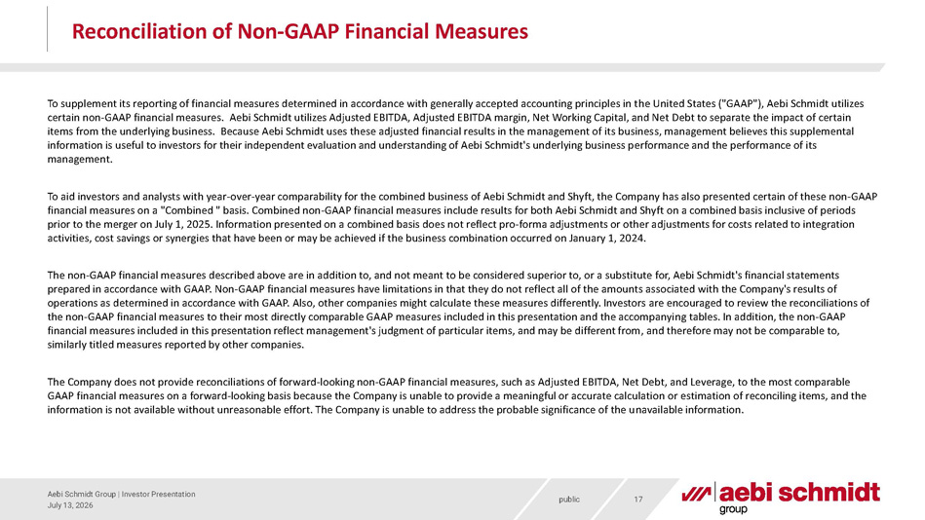
public July 13, 2026 Aebi Schmidt Group | Investor Presentation 17 Reconciliation of Non - GAAP Financial Measures To supplement its reporting of financial measures determined in accordance with generally accepted accounting principles in t he United States ("GAAP"), Aebi Schmidt utilizes certain non - GAAP financial measures. Aebi Schmidt utilizes Adjusted EBITDA, Adjusted EBITDA margin, Net Working Capital, and Ne t Debt to separate the impact of certain items from the underlying business. Because Aebi Schmidt uses these adjusted financial results in the management of its busines s, management believes this supplemental information is useful to investors for their independent evaluation and understanding of Aebi Schmidt's underlying business p erf ormance and the performance of its management. To aid investors and analysts with year - over - year comparability for the combined business of Aebi Schmidt and Shyft, the Company has also presented certain of these non - GAAP financial measures on a "Combined " basis. Combined non - GAAP financial measures include results for both Aebi Schmidt and Shyft on a combined basis inclusive of periods prior to the merger on July 1, 2025. Information presented on a combined basis does not reflect pro - forma adjustments or other a djustments for costs related to integration activities, cost savings or synergies that have been or may be achieved if the business combination occurred on January 1, 20 24. The non - GAAP financial measures described above are in addition to, and not meant to be considered superior to, or a substitute for, Aebi Schmidt's financial statements prepared in accordance with GAAP. Non - GAAP financial measures have limitations in that they do not reflect all of the amounts as sociated with the Company's results of operations as determined in accordance with GAAP. Also, other companies might calculate these measures differently. Investors ar e encouraged to review the reconciliations of the non - GAAP financial measures to their most directly comparable GAAP measures included in this presentation and the accompanyi ng tables. In addition, the non - GAAP financial measures included in this presentation reflect management's judgment of particular items, and may be different from , a nd therefore may not be comparable to, similarly titled measures reported by other companies. The Company does not provide reconciliations of forward - looking non - GAAP financial measures, such as Adjusted EBITDA, Net Debt, and Leverage, to the most comparable GAAP financial measures on a forward - looking basis because the Company is unable to provide a meaningful or accurate calculation or estimation of reconciling items, and the information is not available without unreasonable effort. The Company is unable to address the probable significance of the u nav ailable information.

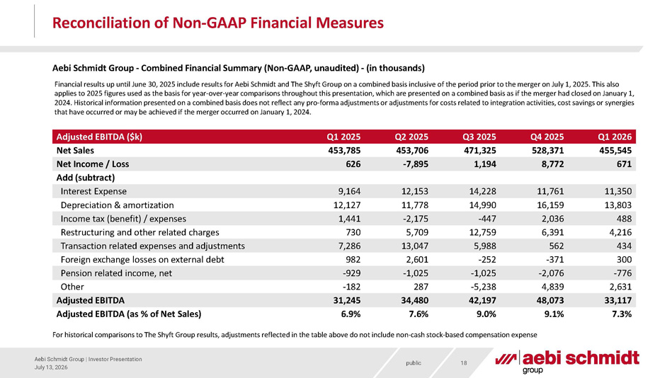
public July 13, 2026 Aebi Schmidt Group | Investor Presentation 18 Reconciliation of Non - GAAP Financial Measures Aebi Schmidt Group - Combined Financial Summary (Non - GAAP, unaudited) - (in thousands) For historical comparisons to The Shyft Group results, adjustments reflected in the table above do not include non - cash stock - ba sed compensation expense Adjusted EBITDA ($k) Q1 2025 Net Sales 453,785 Q2 2025 Q3 2025 Q4 2025 Q1 2026 453,706 471,325 528,371 455,545 Net Income / Loss 626 - 7,895 1,194 8,772 671 Add (subtract) Interest Expense 9,164 12,153 14,228 11,761 11,350 Depreciation & amortization 12,127 11,778 14,990 16,159 13,803 Income tax (benefit) / expenses 1,441 - 2,175 - 447 2,036 488 Restructuring and other related charges 730 5,709 12,759 6,391 4,216 Transaction related expenses and adjustments 7,286 13,047 5,988 562 434 Foreign exchange losses on external debt 982 2,601 - 252 - 371 300 Pension related income, net - 929 - 1,025 - 1,025 - 2,076 - 776 Other - 182 287 - 5,238 4,839 2,631 Adjusted EBITDA 31,245 34,480 42,197 48,073 33,117 Adjusted EBITDA (as % of Net Sales) 6.9% 7.6% 9.0% 9.1% 7.3% Financial results up until June 30, 2025 include results for Aebi Schmidt and The Shyft Group on a combined basis inclusive o f t he period prior to the merger on July 1, 2025. This also applies to 2025 figures used as the basis for year - over - year comparisons throughout this presentation, which are presented on a combined basis as if the merger had closed on January 1, 2024. Historical information presented on a combined basis does not reflect any pro - forma adjustments or adjustments for costs r elated to integration activities, cost savings or synergies that have occurred or may be achieved if the merger occurred on January 1, 2024.

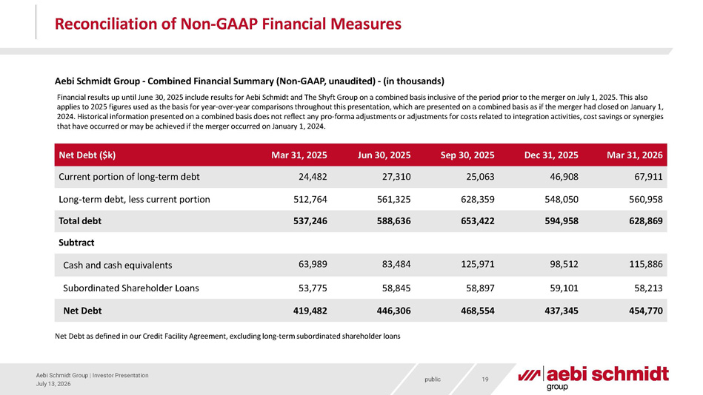
public July 13, 2026 Aebi Schmidt Group | Investor Presentation 19 Reconciliation of Non - GAAP Financial Measures Aebi Schmidt Group - Combined Financial Summary (Non - GAAP, unaudited) - (in thousands) Net Debt as defined in our Credit Facility Agreement, excluding long - term subordinated shareholder loans Net Debt ($k) Mar 31, 2025 Long - term debt, less current portion 512,764 Jun 30, 2025 Sep 30, 2025 Dec 31, 2025 Mar 31, 2026 561,325 628,359 548,050 560,958 Cash and cash equivalents Subordinated Shareholder Loans 53,775 58,845 58,897 59,101 58,213 Net Debt 419,482 446,306 468,554 437,345 454,770 Current portion of long - term debt 24,482 27,310 25,063 46,908 67,911 Total debt 537,246 588,636 653,422 594,958 628,869 Subtract 63,989 83,484 125,971 98,512 115,886 Financial results up until June 30, 2025 include results for Aebi Schmidt and The Shyft Group on a combined basis inclusive o f t he period prior to the merger on July 1, 2025. This also applies to 2025 figures used as the basis for year - over - year comparisons throughout this presentation, which are presented on a combined basis as if the merger had closed on January 1, 2024. Historical information presented on a combined basis does not reflect any pro - forma adjustments or adjustments for costs r elated to integration activities, cost savings or synergies that have occurred or may be achieved if the merger occurred on January 1, 2024.

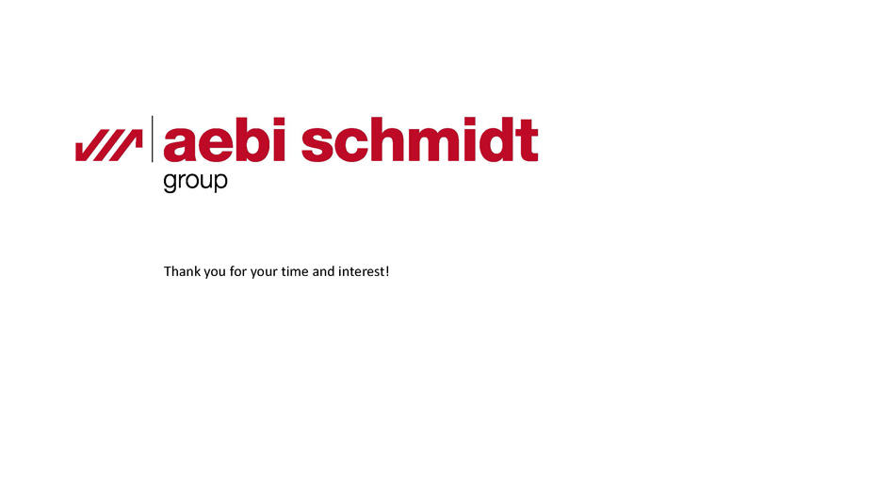
Disclaimer: The information and materials in this document (the “Materials”) have been prepared by Aebi Schmidt Group (hereinafter «ASG») fo r information and discussion purposes only. While ASG believes that all information in the Materials is materially accurate, ASG makes no warranty as to its completeness or accuracy. If the Materia ls refer to financials, they do not purport to show actual results. Information and opinions expressed herein are current as of the date of the Materials only and are subject to change without notice. ASG undertakes no ob ligation to correct, update or revise any information or statements or to otherwise provide any additional materials. Any information on products, projects, financial projections, outlooks, estimates or other statemen ts predicting future outcomes (regardless of whether they are qualified with language indicating that they are opinions rather than fact) are forward - looking statements and are based upon certain assumptions. Events which wer e not accounted for could occur and could significantly affect the potential results discussed herein. Any projections, outlooks, estimates or assumptions should not be construed to be indicative of the actual eve nts which will occur. If any of the assumptions used do not prove to be true, results are likely to vary materially and adversely. The Materials are confidential and any distribution of them to any person other than the pe rso n to whom this information was originally delivered and/or to such person’s advisors is unauthorized, and any reproduction of these materials, in whole or in part, or the disclosure of any of the contents, without th e prior consent of ASG in each such instance is prohibited. The recipient may not rely on the statements contained herein. ASG shall not have any liability for any damages of any kind whatsoever relating to this Materia ls. By viewing and/or accepting the Materials in this presentation, the recipient acknowledges, understands and accepts the foregoing. Thank you for your time and interest!

